TITLE OF ABSTRACT (Centered, 14 Points, Bold)

A. LastName¹, B. LastName¹, C. LastName²
¹University, Department, Mailing address, author1@company.net
²Company, Mailing address, author2@company.net

ABSTRACT (Centered, 12 Points, Bold)

The aim of the present project is to obtain a better understanding of wakes generated by wind turbine rotors. To accomplish this a … The study also provides evidence of…

Place here your maximum 1 page abstract. Use 11 point Times New Roman (Normal Style). The abstract should summarize the context of the presentation. It will be published in the book of abstracts.

Graphs, figures and tables must have a caption. Captions should be centered at the foot of the figure and typed in the same 11 point font used in the paper. References should be noted with square brackets [1] and figures with “fig.1”.

Please submit the abstract in PDF format on the website http://eawephdseminar.sciencesconf.org by 31 May 2013.

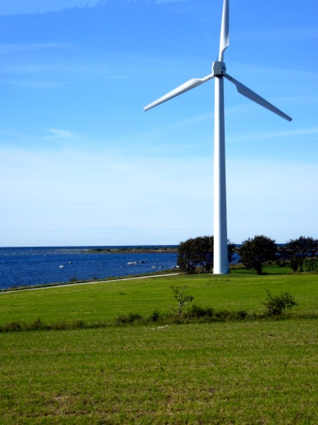

Figure 1: Example of a figure.

REFERENCES (Centered, 12 Points, Bold)
- S. Ivanell, J.N. Sørensen, “Wakes”, Journal of wakes, vol.2 (2004) pp. 695-706.

